Partial / residual correlation: USDCHF and USDCAD
Method 07 / daily log returns / leave-currency-out USD factor / Alpari D1 full available history

Study setup
Logical pair: USDCHF , USDCAD
Broker symbols: USDCHF_i , USDCAD_i
Snapshot: 2026-11-03_majors_alpari_D1
Timeframe: D1
Matched return window: 1999-01-05 to 2026-11-02 (UTC bar dates)
Matched return count n: 7148
Dropped unfinished last bar dated 2026-11-03 UTC after a tick-volume check against the prior complete day.
USD-strength sign rule: minus log return when USD is the quote (EURUSD, GBPUSD, AUDUSD, NZDUSD); plus log return when USD is the base (USDJPY, USDCHF, USDCAD). EURGBP is never a constituent.
Control z constituents (5): EURUSD, GBPUSD, AUDUSD, NZDUSD, USDJPY
z_t = equal-weight mean of those USD-strength returns on the same day
Complete matched rows (Excel): USDCHF-USDCAD_Partial_D1.xlsx
Complete matched rows (HTML table): USDCHF-USDCAD_Partial_D1_data.html

Method carried forward
Partial / residual correlation regresses each matched daily log return of close, ln(close_t / close_t-1), on the same leave-currency-out USD strength factor z, then takes Pearson correlation of the two residual series. Quotes are not inverted. z is the equal-weight mean of USD-strength returns from other majors that do not share a non-USD currency with either leg; EURGBP is never a constituent. USD-strength is minus the log return when USD is the quote (EURUSD, GBPUSD, AUDUSD, NZDUSD) and plus the log return when USD is the base (USDJPY, USDCHF, USDCAD). OLS uses an intercept on each leg. rho_partial is symmetric under swap of the two symbols. It describes leftover linear co-movement after removing linear z; it is not a cause, not a lead, and not a trading signal. Daily rows are not independent and residuals are estimated, so the two-sided p-value and Fisher interval are secondary. Same-sample raw Pearson r is a side check only.

Regression on z
leg | intercept_a_or_c | slope_b_or_d | R2
USDCHF | -7.35e-05 | 0.84328248 | 0.39470744
USDCAD | -1.529e-05 | 0.63039667 | 0.36225415

Results
rho_partial: -0.118976
Two-sided p-value: 5.93024e-24
Approximate 95% Fisher interval: [-0.141768, -0.096058]
Same-sample raw Pearson r: 0.304212
rho_partial minus r: -0.423188

Conclusion
Over 7148 matched daily rows for USDCHF and USDCAD after removing a leave-currency-out USD factor built from 5 constituents, rho_partial is -0.1190 (negative, weak residual linear link in this sample). Approximate 95% Fisher interval: [-0.1418, -0.0961]. Same-sample raw Pearson r is 0.3042 (partial minus r = -0.4232). Leg R-squared on z: USDCHF=0.3947, USDCAD=0.3623. Two-sided p under the usual independent-pairs model is 5.93e-24; residuals are estimated and daily FX rows are linked, so treat p as secondary. This does not establish cause, lead-lag, or a lasting trading rule.

Charts
Daily closes
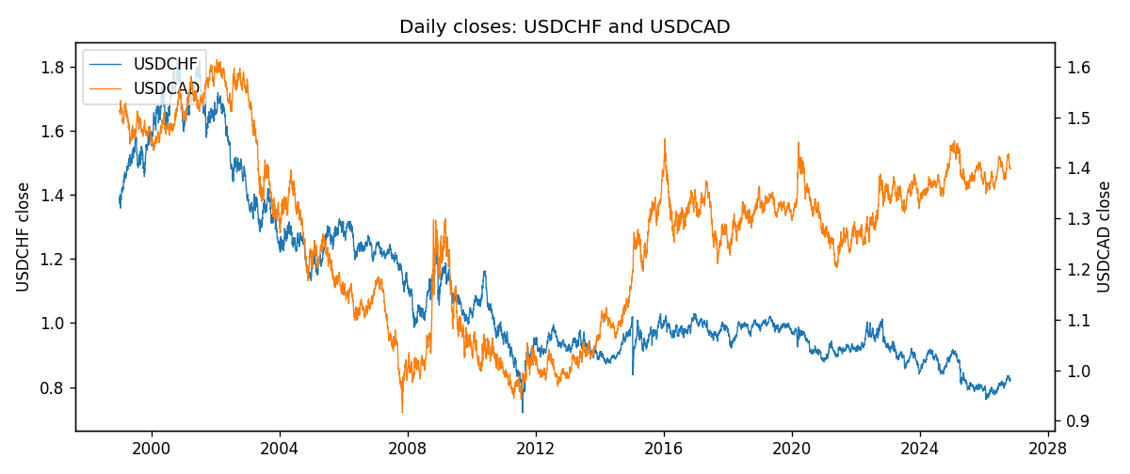
Log returns and control z
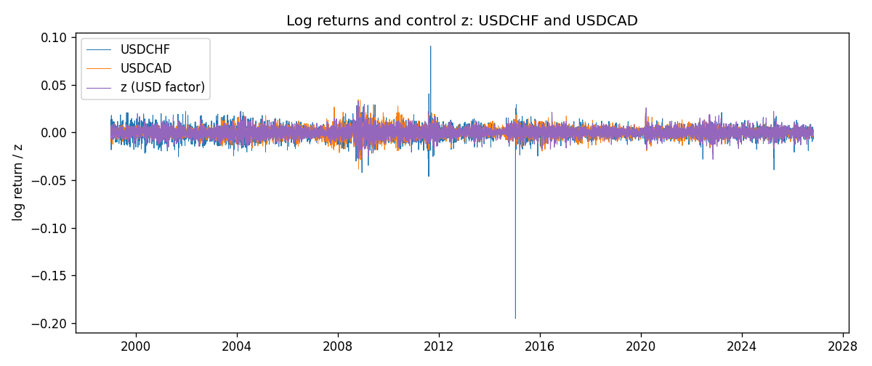
Residual scatter e_x vs e_y
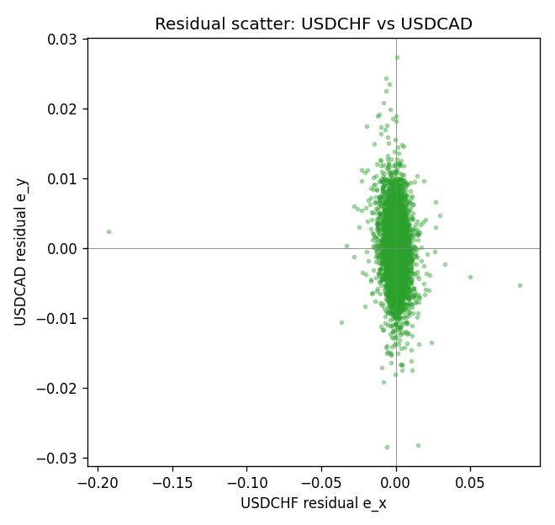

Data report
Every matched row that entered the partial correlation is stored in the sibling Excel workbook named USDCHF-USDCAD_Partial_D1.xlsx. That file is the complete data archive for redrawing charts. Embedding all rows as a Word table is impractical at this length; the Word file holds the column list, column summaries, and the first and last 15 matched rows.
Columns: time, USDCHF_open, USDCAD_open, USDCHF_high, USDCAD_high, USDCHF_low, USDCAD_low, USDCHF_close, USDCAD_close, USDCHF_tick_volume, USDCAD_tick_volume, USDCHF_spread, USDCAD_spread, USDCHF_real_volume, USDCAD_real_volume, USDCHF_log_return, USDCAD_log_return, usd_strength_EURUSD, usd_strength_GBPUSD, usd_strength_AUDUSD, usd_strength_NZDUSD, usd_strength_USDJPY, z, USDCHF_fitted, USDCAD_fitted, USDCHF_resid, USDCAD_resid
Column summaries (matched calculation rows)
column | count | mean | std | min | 25% | 50% | 75% | max
USDCHF_open | 7148 | 1.0960885 | 0.25173228 | 0.72022 | 0.9203525 | 0.9894 | 1.2355 | 1.8219
USDCAD_open | 7148 | 1.2664001 | 0.16881677 | 0.9168 | 1.1174225 | 1.29842 | 1.3719025 | 1.6183
USDCHF_high | 7148 | 1.101368 | 0.25346299 | 0.73305 | 0.9245 | 0.993025 | 1.240225 | 1.8313
USDCAD_high | 7148 | 1.2712993 | 0.16876756 | 0.9336 | 1.1224 | 1.30385 | 1.3760825 | 1.619
USDCHF_low | 7148 | 1.0909798 | 0.25015306 | 0.08565 | 0.9169075 | 0.98582 | 1.229425 | 1.8121
USDCAD_low | 7148 | 1.2618444 | 0.16884966 | 0.9056 | 1.1128375 | 1.29351 | 1.367575 | 1.6102
USDCHF_close | 7148 | 1.0960817 | 0.25162815 | 0.72025 | 0.92048 | 0.989445 | 1.2352 | 1.8217
USDCAD_close | 7148 | 1.2664179 | 0.16878481 | 0.916 | 1.117435 | 1.298405 | 1.3722025 | 1.6137
USDCHF_tick_volume | 7148 | 74666.538 | 113693.11 | 350 | 12884 | 40421 | 70666.5 | 858589
USDCAD_tick_volume | 7148 | 81445.79 | 147602.47 | 56 | 5642.25 | 41126 | 71764.5 | 1410818
USDCHF_spread | 7148 | 25.894096 | 24.64185 | 0 | 5 | 16 | 50 | 100
USDCAD_spread | 7148 | 23.322888 | 18.222444 | 0 | 9 | 17 | 40 | 60
USDCHF_real_volume | 7148 | 2.3408849e+10 | 8.9348471e+10 | 0 | 0 | 0 | 0 | 1.9331921e+12
USDCAD_real_volume | 7148 | 1.8476363e+10 | 9.6948735e+10 | 0 | 0 | 0 | 0 | 2.5751613e+12
USDCHF_log_return | 7148 | -6.945e-05 | 0.0065937 | -0.19545699 | -0.00334697 | 8.15e-05 | 0.00331954 | 0.09051364
USDCAD_log_return | 7148 | -1.226e-05 | 0.00514518 | -0.03859748 | -0.00283513 | 4.873e-05 | 0.00272781 | 0.03436319
usd_strength_EURUSD | 7148 | 2.16e-06 | 0.0058013 | -0.03433183 | -0.00325609 | -0 | 0.00324218 | 0.03123819
usd_strength_GBPUSD | 7148 | 1.992e-05 | 0.00564699 | -0.03112653 | -0.00318167 | -3.426e-05 | 0.0031217 | 0.08388241
usd_strength_AUDUSD | 7148 | -3.157e-05 | 0.00755018 | -0.0806166 | -0.00415111 | -0.00029168 | 0.00385014 | 0.08602525
usd_strength_NZDUSD | 7148 | -1.914e-05 | 0.00764519 | -0.05966839 | -0.004586 | -0.00023666 | 0.00424201 | 0.07027433
usd_strength_USDJPY | 7148 | 5.267e-05 | 0.00620906 | -0.03908203 | -0.00319392 | 0.00012736 | 0.00340928 | 0.05184024
z | 7148 | 4.81e-06 | 0.0049124 | -0.02821331 | -0.0028712 | 1.087e-05 | 0.00284943 | 0.03258501
USDCHF_fitted | 7148 | -6.945e-05 | 0.00414254 | -0.0238653 | -0.00249474 | -6.434e-05 | 0.00232937 | 0.02740486
USDCAD_fitted | 7148 | -1.226e-05 | 0.00309676 | -0.01780087 | -0.00182528 | -8.44e-06 | 0.00178098 | 0.02052619
USDCHF_resid | 7148 | -0 | 0.00512993 | -0.19287735 | -0.00231049 | 0.00011719 | 0.00239575 | 0.08288347
USDCAD_resid | 7148 | 0 | 0.00410889 | -0.02846234 | -0.00232492 | 2.188e-05 | 0.00232299 | 0.02737535
First 15 matched rows (selected columns)
time | USDCHF_close | USDCAD_close | USDCHF_log_return | USDCAD_log_return | z | USDCHF_fitted | USDCAD_fitted | USDCHF_resid | USDCAD_resid
1999-01-05 | 1.3724 | 1.5123 | 0.0039424743 | -0.010131666 | 0.0020435903 | 0.0016498197 | 0.0012729813 | 0.0022926545 | -0.011404647
1999-01-06 | 1.3912 | 1.5118 | 0.013605652 | -0.0003306769 | 0.0011673185 | 0.00091087506 | 0.0007205825 | 0.012694777 | -0.0010512594
1999-01-07 | 1.3782 | 1.5141 | -0.0093883841 | 0.0015202092 | -0.006704456 | -0.0057272544 | -0.0042417579 | -0.0036611297 | 0.0057619671
1999-01-08 | 1.3935 | 1.511 | 0.011040268 | -0.0020495197 | 0.0024530071 | 0.0019950737 | 0.0015310763 | 0.0090451943 | -0.0035805961
1999-01-11 | 1.4009 | 1.5057 | 0.0052963193 | -0.0035137769 | -0.0041837619 | -0.0036015973 | -0.0026527207 | 0.0088979165 | -0.0008610562
1999-01-12 | 1.3872 | 1.5157 | -0.0098275602 | 0.0066194721 | 0.0071421777 | 0.0059493692 | 0.0044871139 | -0.015776929 | 0.0021323583
1999-01-13 | 1.3621 | 1.5226 | -0.018259701 | 0.0045420214 | 0.0012046729 | 0.0009423754 | 0.00074413061 | -0.019202076 | 0.0037978908
1999-01-14 | 1.3588 | 1.5332 | -0.0024256692 | 0.0069376546 | 0.00018898646 | 8.5864788e-05 | 0.00010384523 | -0.002511534 | 0.0068338094
1999-01-15 | 1.3834 | 1.5245 | 0.01794228 | -0.0056905671 | 0.0022126493 | 0.0017923842 | 0.0013795556 | 0.016149896 | -0.0070701227
1999-01-18 | 1.379 | 1.526 | -0.0031856384 | 0.00098344542 | -0.00076709718 | -0.0007203838 | -0.00049886671 | -0.0024652546 | 0.0014823121
1999-01-19 | 1.3789 | 1.5302 | -7.2518946e-05 | 0.002748513 | -0.0032812806 | -0.0028405506 | -0.0020837996 | 0.0027680317 | 0.0048323125
1999-01-20 | 1.3889 | 1.5211 | 0.0072259871 | -0.0059646885 | -0.00052376623 | -0.00051518707 | -0.00034547169 | 0.0077411741 | -0.0056192168
1999-01-21 | 1.3836 | 1.5146 | -0.0038232689 | -0.0042823796 | -0.00051015497 | -0.00050370893 | -0.0003368912 | -0.0033195599 | -0.0039454884
1999-01-22 | 1.3834 | 1.5184 | -0.0001445609 | 0.0025057712 | 0.0058150092 | 0.0048301912 | 0.0036504712 | -0.0049747521 | -0.0011447001
1999-01-25 | 1.3868 | 1.5197 | 0.0024546976 | 0.00085579808 | 0.00039374036 | 0.00025853016 | 0.00023292141 | 0.0021961675 | 0.00062287668
Last 15 matched rows (selected columns)
time | USDCHF_close | USDCAD_close | USDCHF_log_return | USDCAD_log_return | z | USDCHF_fitted | USDCAD_fitted | USDCHF_resid | USDCAD_resid
2026-10-13 | 0.83244 | 1.4214 | -0.0024955621 | -0.0046395653 | -0.0035020796 | -0.0030267465 | -0.0022229905 | 0.00053118445 | -0.0024165748
2026-10-14 | 0.83489 | 1.42356 | 0.0029388325 | 0.0015184751 | 0.0028000927 | 0.0022877649 | 0.0017498779 | 0.00065106754 | -0.00023140283
2026-10-15 | 0.82676 | 1.41843 | -0.0097855323 | -0.0036101503 | -0.0022548326 | -0.001974965 | -0.0014367301 | -0.0078105673 | -0.0021734202
2026-10-16 | 0.82377 | 1.41357 | -0.0036230826 | -0.0034322068 | -0.0030104393 | -0.0026121549 | -0.0019130621 | -0.0010109277 | -0.0015191446
2026-10-19 | 0.82677 | 1.41091 | 0.0036351779 | -0.0018835331 | 0.00016129338 | 6.2511701e-05 | 8.638761e-05 | 0.0035726662 | -0.0019699207
2026-10-20 | 0.8246 | 1.40569 | -0.0026281224 | -0.0037066008 | -0.0034834305 | -0.0030110201 | -0.0022112342 | 0.00038289768 | -0.0014953667
2026-10-21 | 0.82427 | 1.4045 | -0.00040027413 | -0.00084691787 | -0.0015909944 | -0.0014151619 | -0.0010182488 | 0.0010148878 | 0.00017133093
2026-10-22 | 0.82032 | 1.40081 | -0.0048036381 | -0.0026307268 | -0.00053049772 | -0.00052086361 | -0.0003497152 | -0.0042827745 | -0.0022810116
2026-10-23 | 0.82497 | 1.40085 | 0.005652514 | 2.85545e-05 | -0.00033310609 | -0.00035440671 | -0.00022528017 | 0.0060069207 | 0.00025383467
2026-10-26 | 0.82649 | 1.40093 | 0.0018407959 | 5.7106554e-05 | 0.0029862545 | 0.002444752 | 0.0018672337 | -0.00060395602 | -0.0018101272
2026-10-27 | 0.82865 | 1.40449 | 0.0026100526 | 0.0025379458 | 0.0015758716 | 0.0012554007 | 0.00097813301 | 0.0013546519 | 0.0015598128
2026-10-28 | 0.82781 | 1.39911 | -0.0010142111 | -0.0038379274 | 0.00017531369 | 7.4334783e-05 | 9.5225966e-05 | -0.0010885459 | -0.0039331533
2026-10-29 | 0.82379 | 1.39895 | -0.0048680164 | -0.00011436495 | -0.00055122392 | -0.00053834165 | -0.00036278092 | -0.0043296747 | 0.00024841597
2026-10-30 | 0.82438 | 1.39751 | 0.00071594559 | -0.0010298736 | -0.00049289565 | -0.00048915445 | -0.00032601098 | 0.0012051 | -0.00070386259
2026-11-02 | 0.81851 | 1.39837 | -0.0071459744 | 0.00061519094 | 0.0013881903 | 0.0010971324 | 0.00085981934 | -0.0082431068 | -0.0002446284

